Mongodb commands execution – Raghuram Reddy
1. Database Commands
These commands are used to create, select, view, and delete databases.
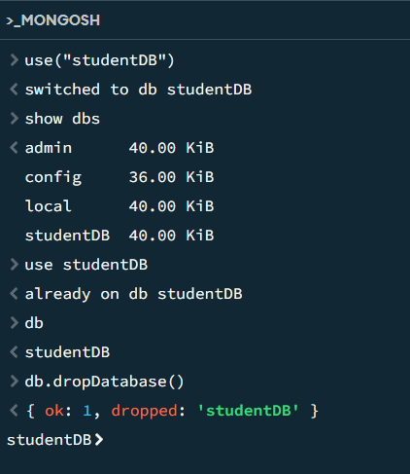
2. Collection Commands
A collection is used to store MongoDB documents. It is similar to a table in a relational database.
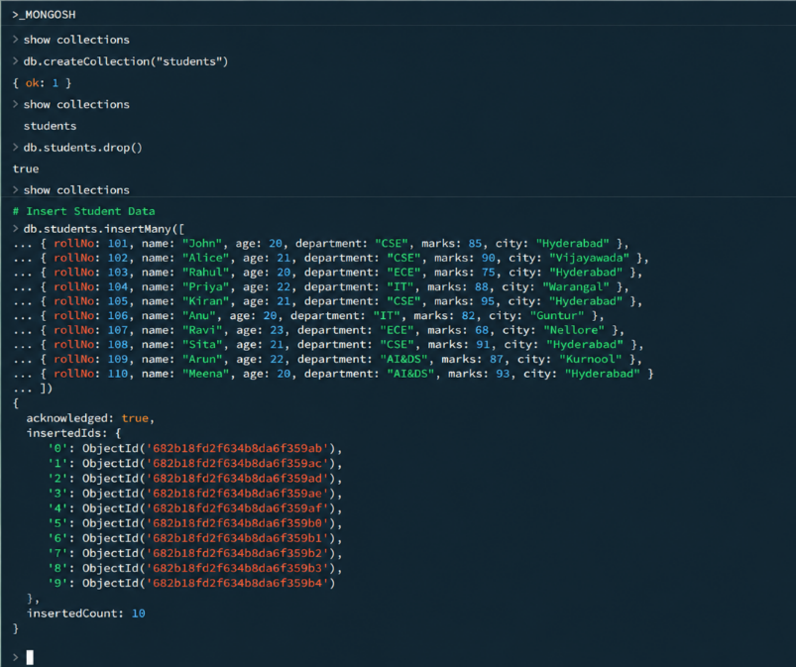
3. Insert Student
This section inserts sample student records into the students collection using insertMany().
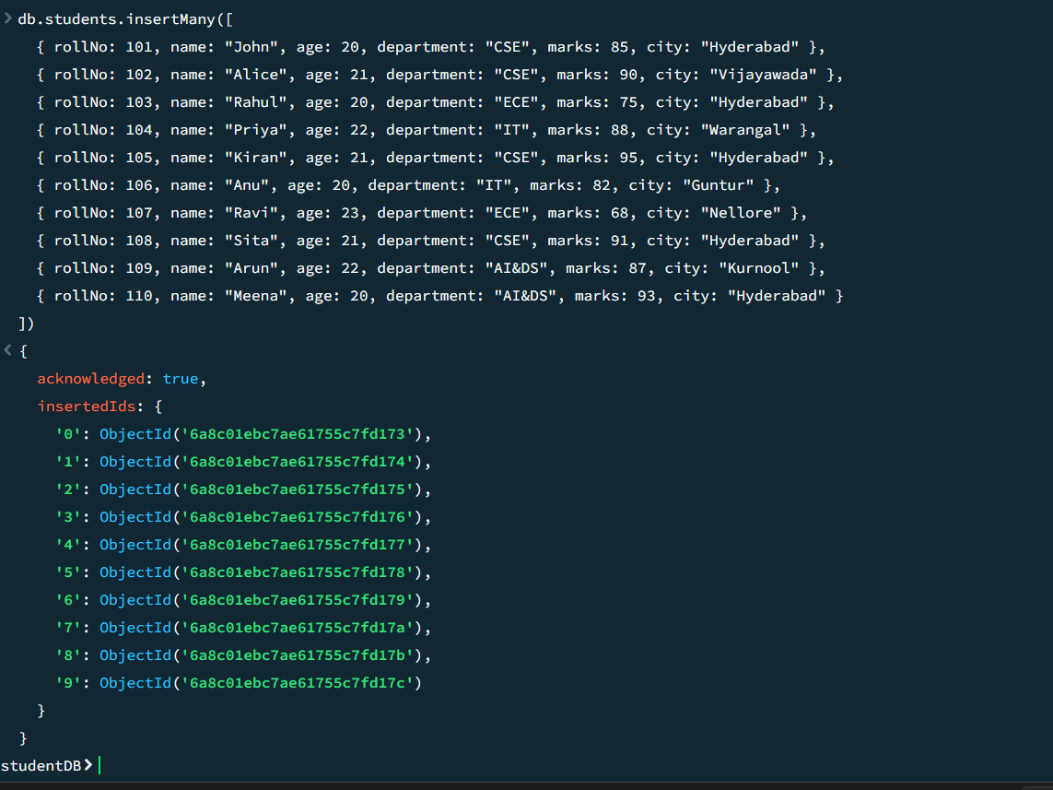

4. CREATE – Insert Commands
The CREATE operation is used to add new documents.
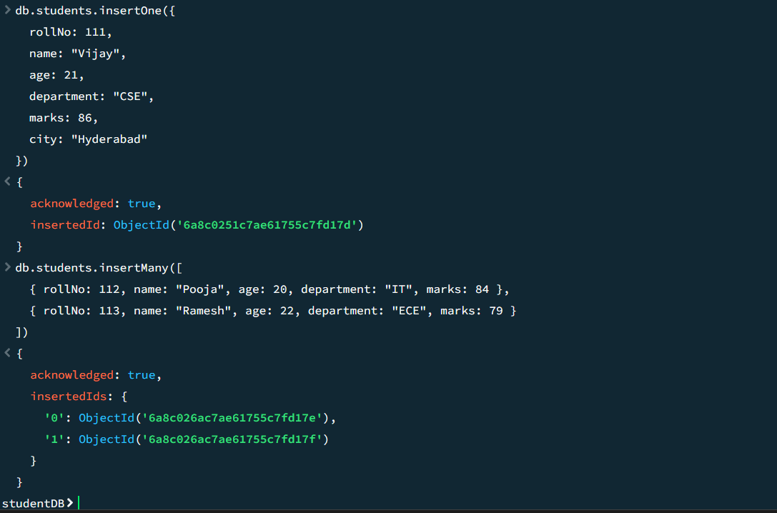

5. READ – Basic Find Commands
READ operations are used to retrieve documents.
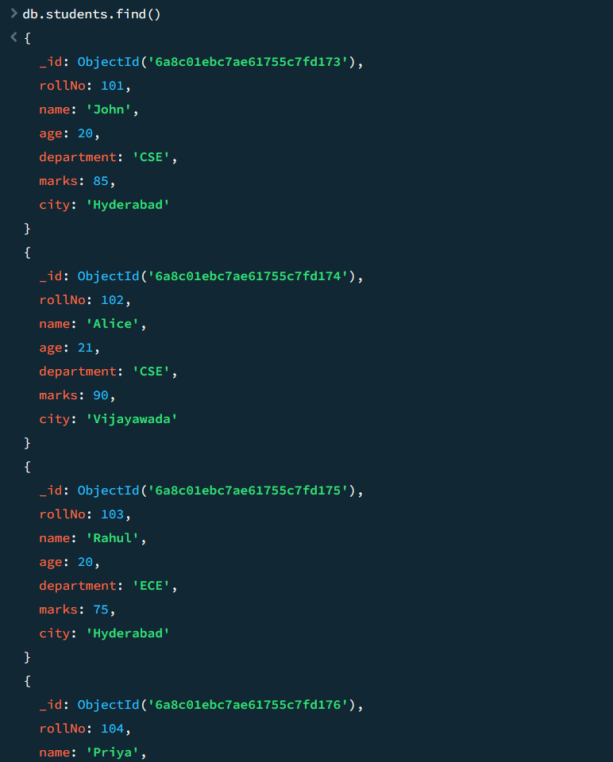
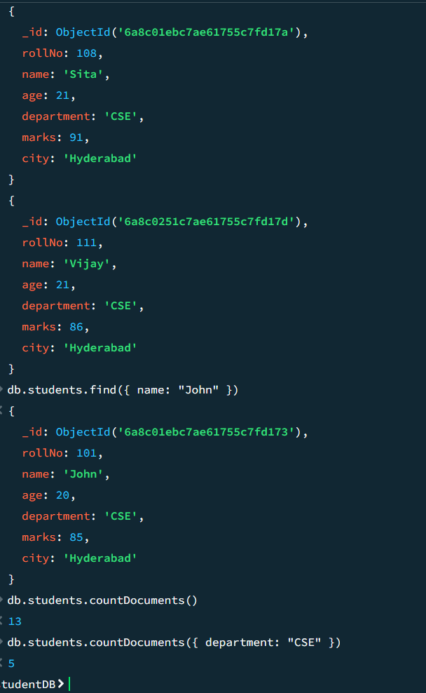

6. Comparison Operators
Comparison operators are used to compare values.
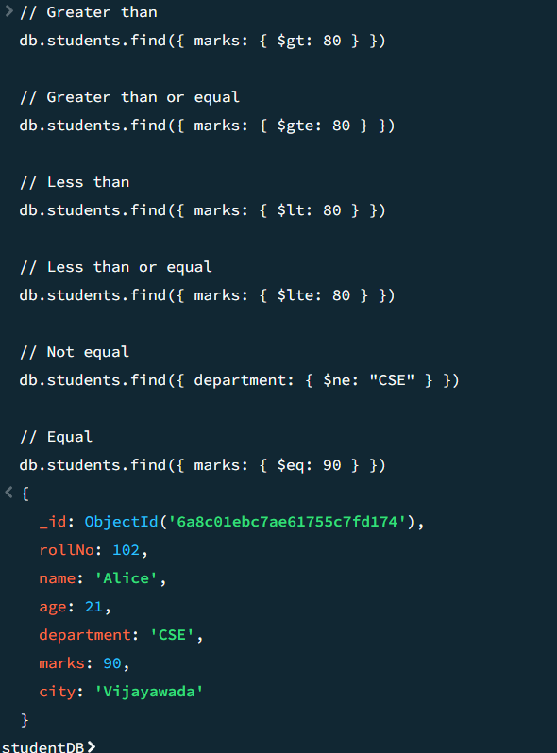

7. Logical Operators
Logical operators are used to combine or reverse conditions.
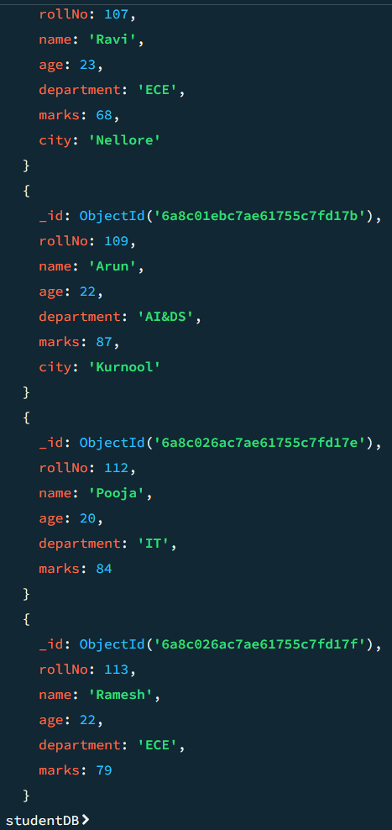

8. IN and NIN Operators
Finds students whose department is either CSE or IT.
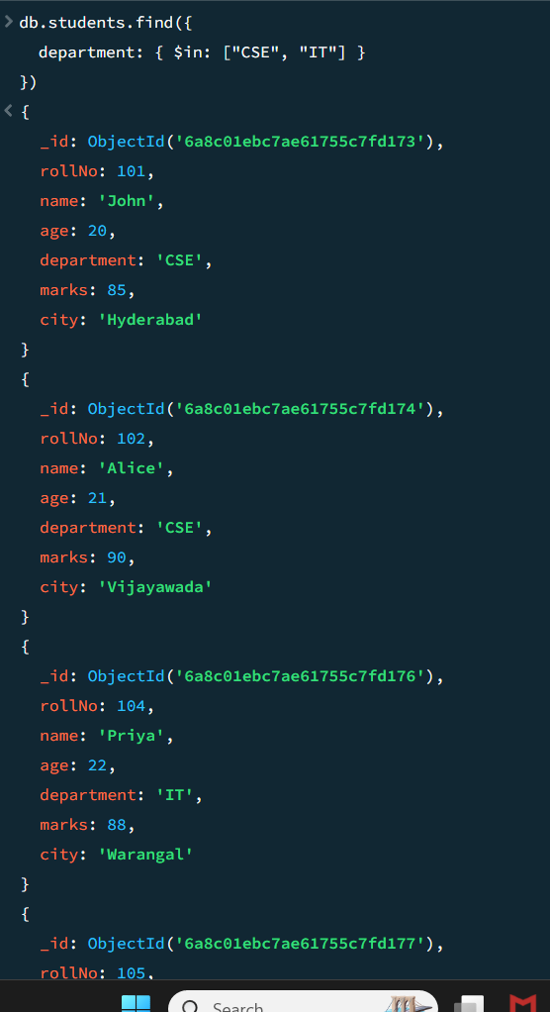
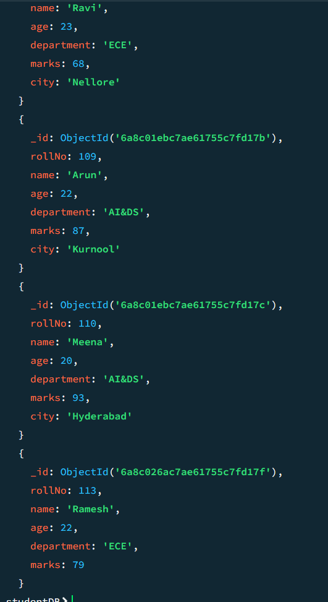

9. UPDATE Commands
UPDATE operations modify existing documents.
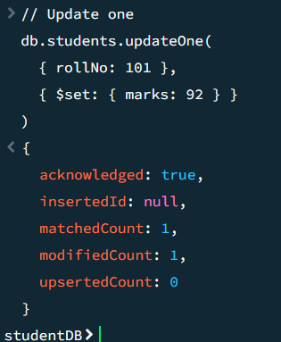
Update multiple
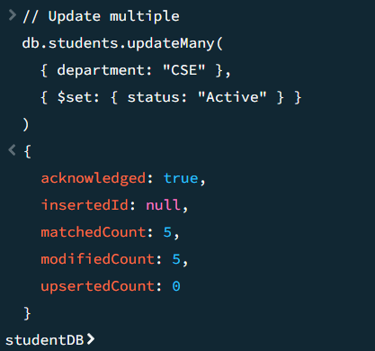
Increment, Decrement, Rename a field, Add a field, Remove a field
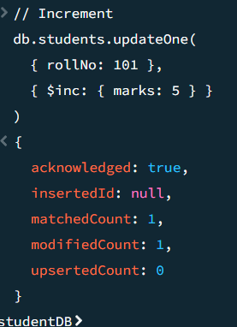

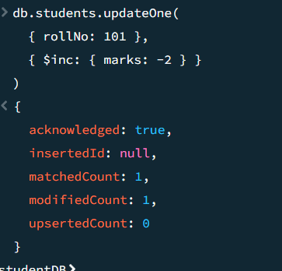
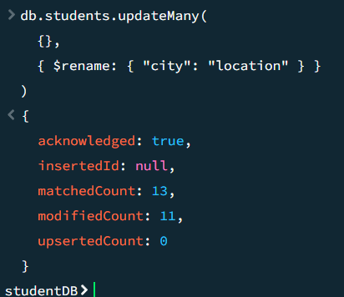
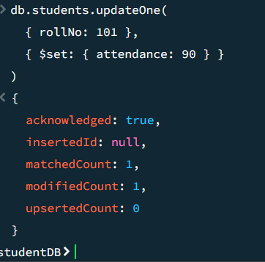
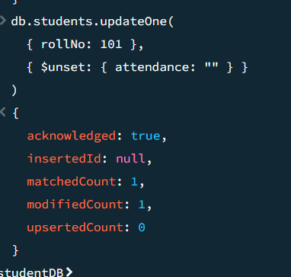

10. DELETE Commands
DELETE operations remove documents.
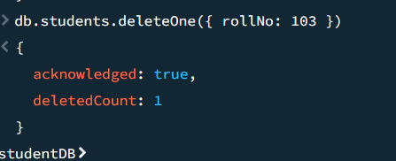
Delete multiple
Delete all documents
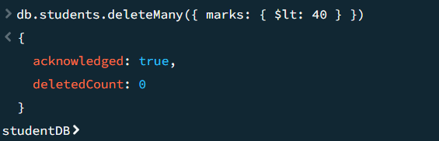
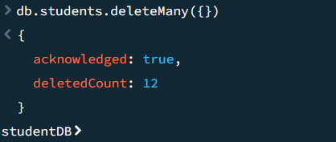

11. Sorting
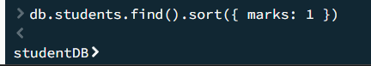
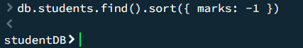

12. Limit and Skip
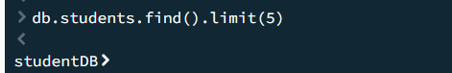
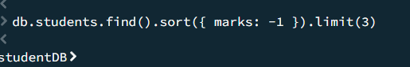
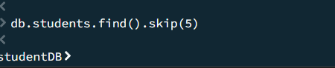
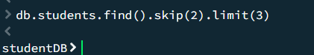

13. Projection
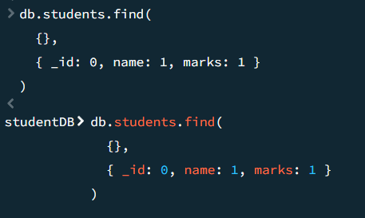
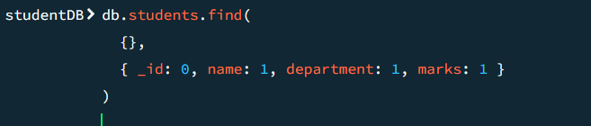
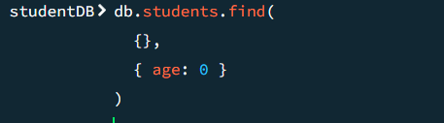

14. Distinct Values
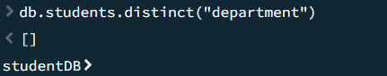
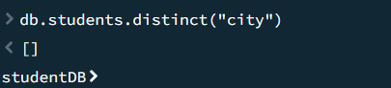
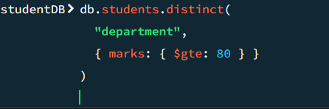

15. Index Commands
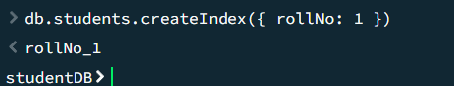
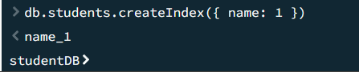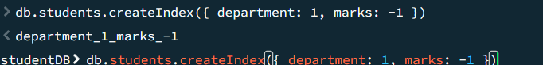
16. Aggregation – Basic Commands
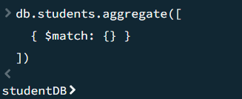
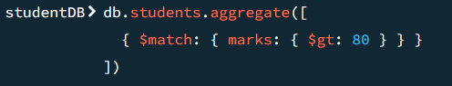
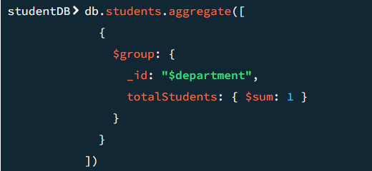
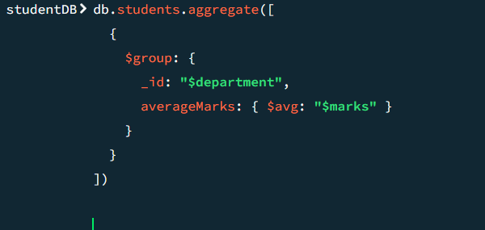

17. Aggregation with Multiple Stages
